**HSBC, San Francisco, CA Mar 2009 to Till Date**

**Senior Business Analyst**

***Business Payroll Services Through ACH Payment Gateway for Corporate Clients***

HSBC provides various financial products and services to consumers, small businesses, and commercial clients.

The project required setting up of direct deposit of the *Payroll Services*for HSBC’s corporate clients through **ACH payment gateway**. Depending on the size of the organization and the number of employees they customized their Payroll Services accordingly.

***Responsibilities:***

* Managed requirements from *system users* and preparation of *business requirement documents* using **Rational Requisite Pro** that provided appropriate scope of work for technical team to develop prototype and overall system.
* Created *UML based diagrams using* **Rational Rose** *and* **MS-Visio** for ***Use Cases*** and ***Activity Diagrams***, for better understanding of the layout of the new process.
* Assisted the Project Manager in preparing the **Project Development Plans.** Also helped in identifying and tracking **Project Issuesand Risks***.*
* Gathered the functional and business requirements by conducting **JAD** sessions and participatory *Design Sessions* involving major leads from the Technical Department.
* *Gathered requirements* and participated in ***database designand development*** as well as ***report design and development***, *testing plan co-development and quality assurance.*
* Developed **Business Requirement Document** and **Use Cases Specification** for various Use Cases.
* Performed ***data conversion, stratification and quality control*** testing of interim and final data and preparation of all **reports and data transmissions**to client for projects.
* Extracted data from Oracle into temporary tables in order to ***cleanup and standardize*** column entries for *re-import into new Oracle data structures*. Used **extensive *ad-hoc queries (SQL) to create/modify/delete data.***
* Worked with the Development and QA team in creating a **demo website for UAT**.
* Created UAT *test scenarios and test cases*and **coordinated UAT**.
* Generated ***Executive Problem Management*** Reports in excel.
* Helped many business clients in getting right and precise information for making better decision.

***Environment***

Rational Rose, Rational Requisite Pro, MS Office Suite, MS Project Plan, Oracle 10g, Business Objects

[**http://infocenter.bankofamerica.com/smallbusiness/ic2/online-business-suite/easy-online-payroll/**](http://infocenter.bankofamerica.com/smallbusiness/ic2/online-business-suite/easy-online-payroll/)

[**http://www.bankofamerica.com/small_business/online_banking_and_services/index.cfm?template=payroll_services**](http://www.bankofamerica.com/small_business/online_banking_and_services/index.cfm?template=payroll_services)

*HSBC (Hong Kong and Shanghai Banking Corporation)*

**Q. Work Location!**

**HSBC Private Bank (Cross Streets – Clay and Montgomery, Washington and Kearny)  
A division of HSBC Bank USA**

(15 minutes walk from **Montgomery**Bart station)  
601 Montgomery Street  
Suite 1850  
San Francisco, CA 94111, USA, Tel (+1) 415 678 3000, Fax (+1) 415 678 3895

**Q. Tell me about the Project?**

A. **HSBC bank caters to both retail and commercial clients.**

This project was specifically directed towards HSBC’s wholesale banking clients, which included large corporations, mid-sized companies, and small businesses. Since it is more attractive for a company to place all their financial matters with a single institution, rather than using different banks and agencies for each banking services, HSBC wanted to provide such complete service package.

This project involved setting up of direct deposit of the Payroll Department for HSBC’s clients through ACH gateway. The client could set up a periodic payroll deposit linked to their account and would no longer have to deal with any physical check handling.

(It was setup using the ADP – Payroll services and they receive features such as ***tax services, direct deposit, W-2s, and 1099 reporting***).

**Q. Give me the details ofthe project?**

The project involved offering the wholesale banking customers the **Easy Online Payroll Suite:** (Which Included)

* **Direct Deposit**
  + Save your employees time by eliminating special trips to the bank to deposit checks
  + Eliminate lost or stolen checks
  + Funds are instantly accessible - no more waiting for checks to clear
  + Bank of America Direct Benefits® employee benefits package included at no additional cost
* **Tax services**
  + · Deposits your federal withholding
  + · Deposits FICA
  + · Deposits other related payroll taxes
  + · Assumes responsibility for the timeliness and accuracy of the returns
  + · Assures compliance with the latest payroll tax regulatory changes
* **W-2s and 1099 reporting**. ADP handles all year-end and tax-filing documentation, saving you time and the risk of errors
* **Bank of America Direct Benefits** - Get an employee banking benefits package at no additional cost when you offer direct deposit.
  + Includes money saving discounts your employees will appreciate
  + Provides incentives for employees to participate in direct deposit
  + Easy to implement - no administrative hassles
* **CashPay** - Direct Deposit for your employees who do not have or want to use a traditional bank account.

<http://www.bankofamerica.com/smallbusiness/treasurymanagement/index.cfm?template=py_payroll.cfm>

**Q. What was the project team size?**

The project team included:

1 Project Managers, 4 BA, 8 QA and 6 Developers

***Client Advantages:***

* Stream line the entire pay process and is safe, simple and convenient.
* Eliminate Delays in check delivery since the funds are automatically transferred.
* Minimized storage and security of check lots.
* Considerable cost reduction.
* Better control on Liquidity of Funds.

***Bank Advantages:***

* Meet all the banking needs of the client and hence better customer loyalty.
* Increase in cash flow and liquidity management leading to financial growth.

**Q. What was your role in the project?**

A. My role in the project was geared towards gathering requirements for the implementation of the ACH for the **Direct Deposit of Payroll.**

* I was involved in the project from start to finish.
* My primary task was to act as a liaison between the business team and the technical team and support the Project manager in implementing project breakdown and schedule milestones.
* I interviewed end users (in this case the Client representatives), also SMEs to identify their requirements.
* I documented the all the requirements in Business Requirement document (BRD), wrote down the functional specifications and assisted in technical design documents.
* I have been involved in meetings with the QA group, the developers, and the UA team to assure on-time and within-budget delivery of the project.

I played a key role in planning, testing and finalizing the ***Client EnrollmentPage***.

I also performed the gap analysis by documented the existing and future business process for new channel partners and performed the business impacts.

I was also involved in conducting UAT – *User acceptance test* - and ran basic queries for QA testing and data validation as well.

**Q. What were the Issues faced during the project?**

A. Some of the major issues faced in the project involved:

* Getting financial information from the User Leads to understand the requirements and the scope of the project.
* Getting a consensus on the extent of services offered to the small business segment.

**Q. What were the Risks involved in the project?**

A. The risks involved with the project included:

* There was a lot of confidential information (SSN numbers, Employer Tax Ids, Employer and Employees personal information, Financial information etc.) involved.
* Risks involved with the security of the information transfer between the bank and partners.
* Low initial *Partner Adoption* rate.
* Problems with bringing new *Partners* on board.
* Service Level Agreement contracts with ADP.

**Q. Whom did you interact during the project for requirements gathering, UAT, etc? Specify their designation and the Reason of Interaction.**

|  |  |
| --- | --- |
| **Customer/Client/SME/End User** | **Reason of Interaction** |
| Customer Rep – **Daniel Sullivan** - Subway | Understanding Business Requirements |
| SME – **Robert Hays** | ACH functionality and Limitations |
| Development Team – **ShawnLovering,Tom Griffith** | Integration Specialist |
| QA – **Shivani Sharma –**QA Lead | Discussed Test Plans and Test Cases |

**Q. What were the Budget, Project Team, and SDLC Method used for this project?**

|  |  |
| --- | --- |
| **Budget** | The budget of the project was $650,000 |
| **SDLC** | The SDLC used was Agile |
| **Database** | Oracle Data Base 9i, Oracle Plus |

**Q. Business Rules?**

* The **NACHA (National Automated Clearing House Association)**rules pertaining to the ***ACH transfers*** had to be followed.
* Information Security had to be the biggest priority.

**Q. Business Requirements?**

* Customer Should be able to enter all their employee information online
* Customer should be able to create different pay categories
* Customer should be able to enter tax details (like Single or Married), 401 K etc.
* Customer should be able to enter over time hours and hourly rate
* Customer should be able to enter sick leave
* Customer should be able to create checks online
* Customer should be able to reprint pay stubs
* Customer should be able to manage/ deduct/ add hours to the employee’s record
* Customer should be able to see and approve the final checks before they print
* Customer should be intimated about the withdrawal from their account once the checks have been printed

**Q. Functional/Non Functional Requirements?**

**Functional**

* User should be able to login into their business account
* User should be able to enroll for the payroll services
* User should be easily able to set up their employee details in the payroll
* User should be able to search for an employee in the payroll services
* User should be able to edit or delete an employee details
* User should be able to get the Year till Date information from the SOR.

**Non-Functional**

* Usage – Customer should be able to login easily into their business account payroll services.
* Security – All the information updated in the system (database) should be fully secure, the channels to transfer the information should be secured as well (HTTPS).
* The infrastructure should be able to support the new requirements.

**Q. What was your experience with users to define Business Requirements?**

I request users for their time in person or over the phone asking what are their expectations are, what are they expecting and what they would like to see in the new application. After taking notes and recording what everyone has to say, would document these finding. Then I send first draft of the requirements based on the template and methodology the company is using for user reviews.

**Q: Describe in detail your experience serving as an interface between the developers and users to translate business requirements into technical specifications.**

I worked as liaison between business team and the technical team; users do not care about technical terms and developers want specific instructions. So my role is always to bridge the communication gap between them. And gather the requirements in details and sit with developers in their designs meeting to make sure they are developing the right product and addressing end users concerns.

**What were some of the requirements you held JAD and JAR sessions for?**

A JAD and/or a JAR session are not always required. JAD/JAR sessions are required when there are requirements conflicts or analysis paralysis. One such requirement that was becoming a pretty big conflict was about how a wholesale customer of HSBC goes about doing direct deposit of payroll for large amounts. There were 2 different thoughts were as follows: 1) Wholesale customers should be able to transmit payroll (direct debit) up to any amount to their employees without requiring special forms to be in place with HSBC 2) Wholesale customers should not be able to transmit unlimited payroll amounts (direct debit) without having specific paper work in place with HSBC. The Legal team and the Finance Team was requiring us to go with Point 2 above whereas the business teams (Customer Support Team) wanted us to go with Point 1 above. I was involved in major discussions about if and when should this check kick in (when the direct deposit payroll amount goes up by how much percentage).

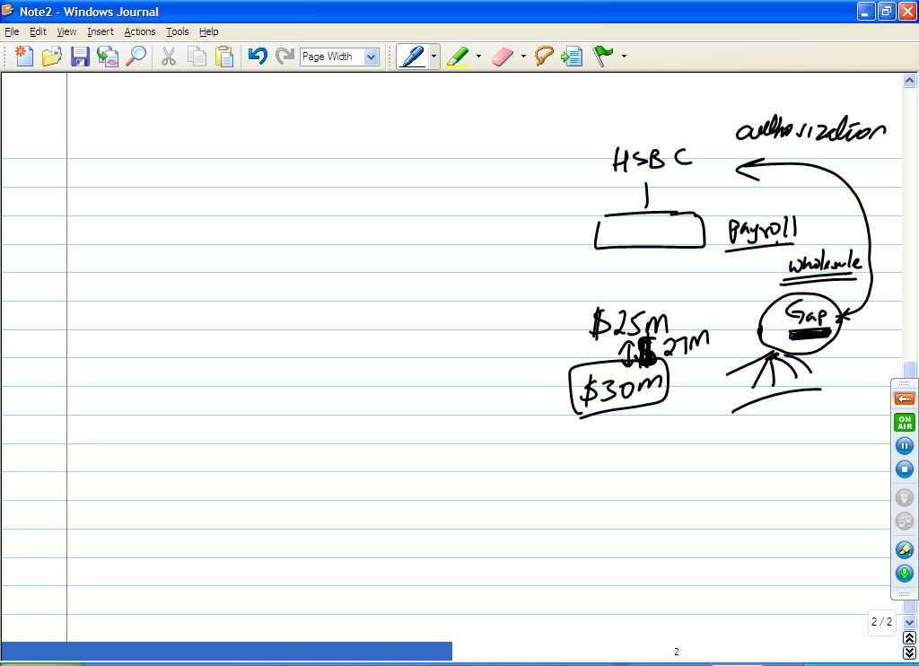

**Q: Describe in detail your experience with process flow diagrams.**

Process flow diagrams are very important in any project, I’ve drawn them using Visio. PFD shows the relationship between the units and general flow of a process.

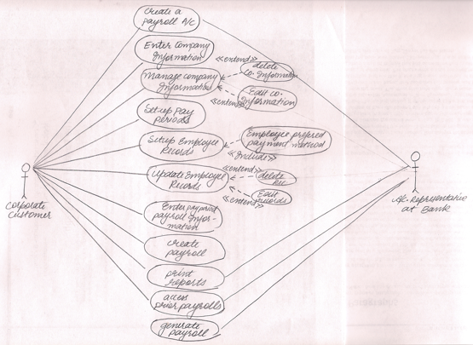

**ACH File Transfer**

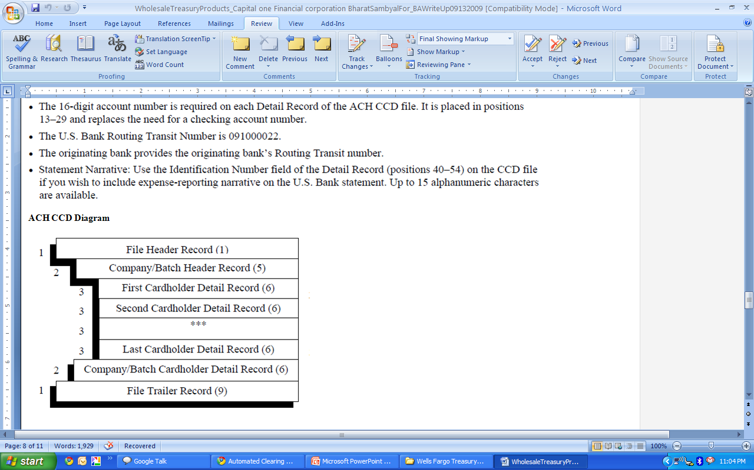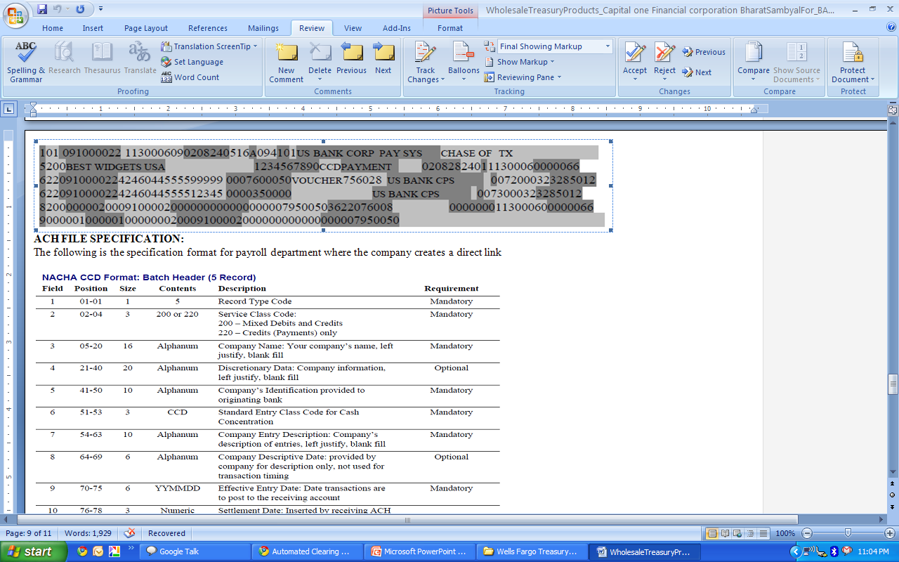

**SEC Codes:**

ARC – Account Receivable Entry

CTX – Corporate Trade Exchange

CCD – Corporate Cash Disbursement

TEL – Telephone Initiated

WEB – Web Initiated

POS – Point of Sale

POP – Point of Purchase

**PPD – Pre-arranged Payment and Deposit (for payroll, interest, pension, dividends)**

**Q. Were you involved in UAT for this application?**

A. Yes I was involved in the UAT for this project. We had created a demo website for the users to experiment with. It worked the same way the final application would have.

We asked them to critique it on the basis of ease of use, user interface design, user requirements met etc.

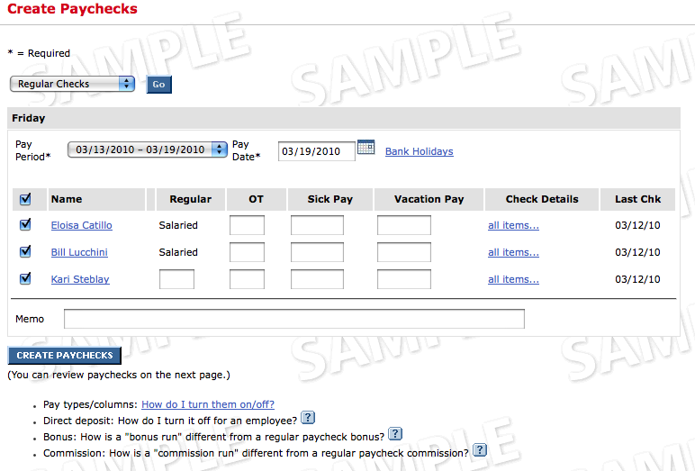

Intimation of the withdrawal:

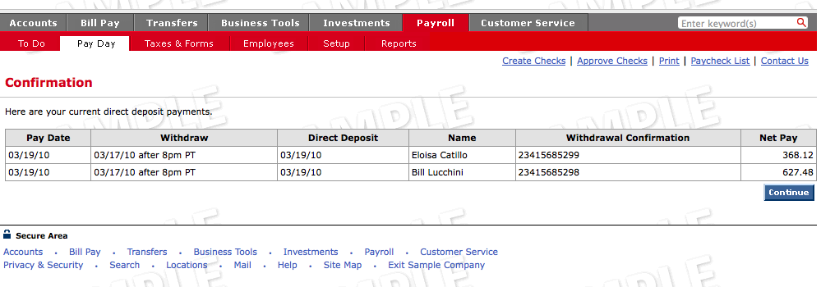

**Small Business Payroll:**

[**http://www.bankofamerica.com/small_business/online_banking_and_services/index.cfm?template=payroll_services**](http://www.bankofamerica.com/small_business/online_banking_and_services/index.cfm?template=payroll_services)

**Q. What is ACH?**

The **Automated Clearing House** is one of the central functions that make modern banking possible. *As a network that allows for the* [*orderly*](http://www.wisegeek.com/what-does-an-orderly-do.htm) *and timely transfer of funds between accounts open with different banking institutions*, the ACH makes it possible for many people to access funds in their accounts much more quickly. Here are some of the ways that the Automatic Clearing House impacts the flow of finances every day.

One of the most important aspects of the Automatic Clearing House is the orderly processing of **Electronic Funds Transfer protocols**. Each [**EFT**](http://www.wisegeek.com/what-is-an-eft.htm) transfer has to coordinate so that funds are removed from one financial account, moved efficiently through the system to terminate in a deposit to a different financial account. The electronic funds transfer network ensures that these transfers are conducted ***quickly and accurately.***

For many years, this function involved moving funds from an account at one bank to a different account at another bank. Today, the use of automated teller machines and online purchasing has made the role of the Automatic Clearing House even more important than ever. Today, people expect to be able to draw funds from any ATM machine, regardless of who owns the machine. The advent of the Internet has also impacted the way people do their banking with the ability to transfer funds from one account to another with ease. Online purchasing with a [debit card](http://www.wisegeek.com/what-is-a-debit-card.htm) also calls for the quickly and orderly transfer of payments form the buyer's account to the seller’s account. All these important functions rely on the competency of the Automatic Clearing House.

The Automatic Clearing House serves as the link between the point of origin of a financial transaction and the point of termination of the transaction. Essentially, one link of the EFT network initiates the transaction. The Automatic Clearing House receives the transaction and then waits for instructions on where to route the transaction for completion. Once that data is received and verified, the funds are sent on to a second link within the system and reach the terminating account.

The process of ***receiving, verification, and release*** of the funds helps to keep transactions orderly and documented. In actual practice, the process may take only a few seconds, although security issues for large amounts of money may take a little longer. There are a number of institutions that work with the Automatic Clearing House, among them the [**Federal Reserve**](http://www.wisegeek.com/what-is-the-federal-reserve.htm) **of the United States, the Electronic Payments Network, and** [**credit card**](http://www.wisegeek.com/what-is-a-credit-card.htm) **giant Visa**.”

**ACH Route:**

Originator – **ODFI (Originating Depository Financial Institution) –** ACH Service Provider – **RDFI (Receiving Depository Financial Institution) –**Receiver

**How did you do (system) testing?**

I conducted System Testing in pretty much every project that I am involved with. In fact, towards the end of a project lifecycle, the role of a BA is diluted unless the BA finds other activities to keep her busy. I have often taken over complete functionalities to test to help out the QA teams. E.g., in my HSBC project, I did end to end System Testing to make sure that our wholesale customers can do account management on our portal and change their profile info like phone number, email id, primary bank account information, dollar limits for each payroll transmission as well as for total payroll amount. I treated the application as a black box, changed some information on account management portal, logged out, logged back in and made sure that the changed information ‘sticks’. I also confirmed this by doing a back end SQL query to confirm that the changes I made on the front end got into the database at the back end.

**System Testing =** Testing that attempts to discover defects that are properties of the entire system rather than of its individual components

For demo on payroll services:

[**http://infocenter.bankofamerica.com/smallbusiness/ic2/online-business-suite/easy-online-payroll/**](http://infocenter.bankofamerica.com/smallbusiness/ic2/online-business-suite/easy-online-payroll/)

**Tell me about your data modeling experience?**

**Yes, I have done data modeling many times over in many projects. In my project with HSBC, I was involved in re-designing the database to accommodate the bigger clients of ours since the old system was not very quick in getting onboard new clients. A project was undertaken to re-create the database from scratch so it had more scalability. I did ER Modeling to understand the various entities that existed in our Payroll service application. I did detailed ER modeling to understand the various attributes of these entities and figured out the relationship between the various entities. I did this using ERWIN, an ER modeling tool.**

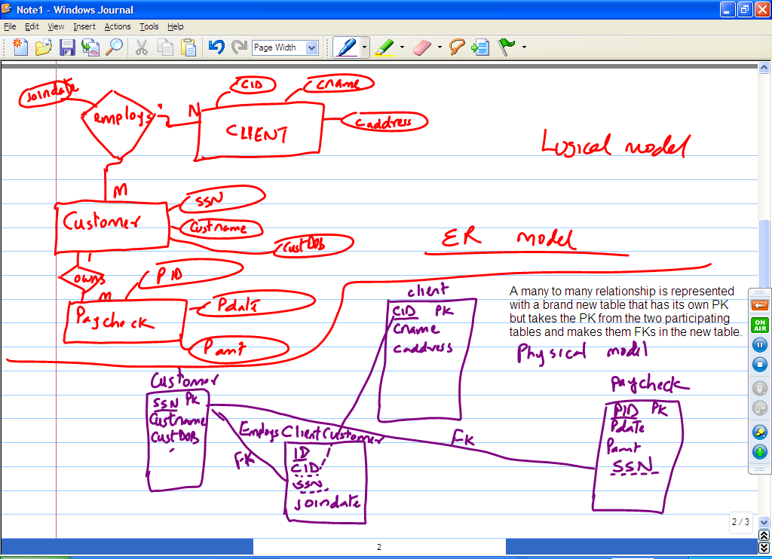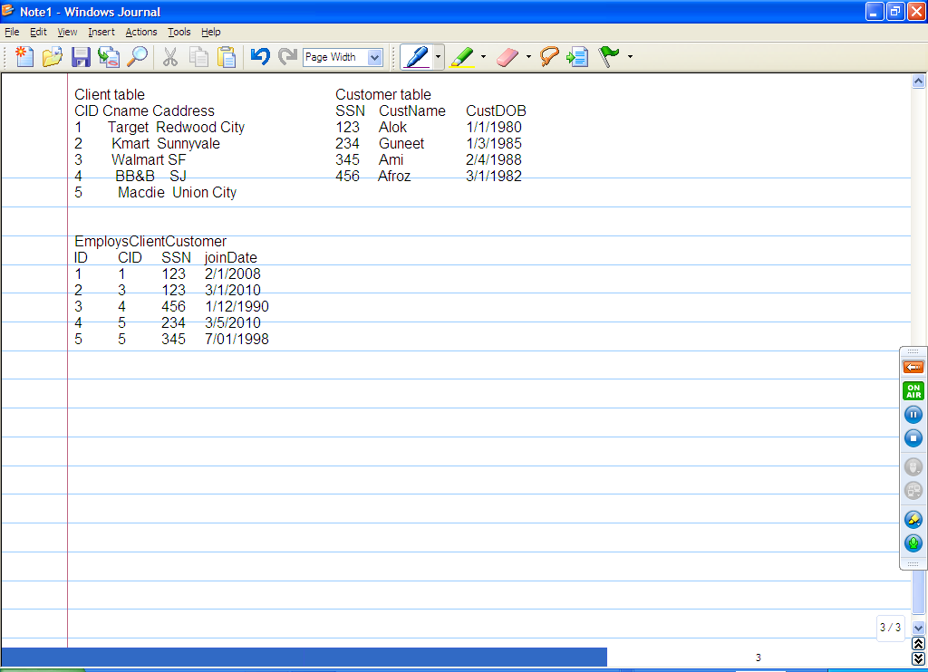

**It is amazing that when this application was first conceived, the project team did not take into account the fact that a single individual customer could possibly work with multiple clients. The old ER modeling team had made the Employs relationship 1 to many. This caused problem in the rare cases where a specific John Doe worked for 2 clients of HSBC. There was no work around for this as in the Customer table, we had SSN as the primary key. So, the only way was for this employee (customer) to get direct deposit through the first client they joined and for the second client, the customer had to pick up paper check!**